Celiac trunk
- Artery of foregut
- Anterior branch of abdominal aorta
[TIP]Development: The celiac trunk appears in the fifth week of embryonic development at the level of the seventh cervical segment

Final adult position
- At the lower third of the first lumbar vertebra

Relation to median arcuate ligament
- Passes in front of the aorta at the level of the first lumbar vertebra, usually just above the origin of the celiac trunk

Relation to celiac ganglia
- The left and right celiac ganglia lie on either side of the base of the celiac trunk, concealing its origin from the aorta
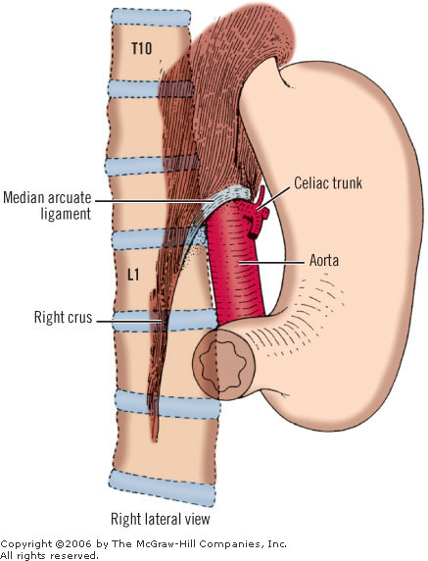

Branches
- Hepatic artery
- Splenic artery
- Left gastric artery (smallest branch)

Largest branch
- In fetus –hepatic artery
- In adult – splenic artery

[CLINICAL]Celiac artery compression syndrome: mostly by the median arcuate ligament

